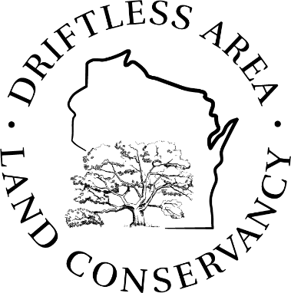**Board Meeting Agenda**

**10:00 am - 2:00 PM, Wednesday, Sept. 10, 2024**

**Wyoming Valley School Cultural Arts Center**

Virtual Option:

<https://us02web.zoom.us/j/88061616471?pwd=QneqetrHmrJ2zpe7DySa0Z9sIusOBh.1>

Meeting ID 880 6161 6471, Passcode 735812

DALC Land Protection Projects - Evaluation & Scoring

Goals:

* Learn how the scoring process is informed by DALC’s mission & goals
* Understand the process used to evaluate potential new projects
* Experience the scoring process!
* Discuss recommendations for prioritization improvements

|  |  |
| --- | --- |
| 9:45 am | Gathering Time, coffee, tea available |
| 10:00 am | Call to Order, review and accept agenda |
| 10:05 am | Secretary’s Minutes (motion to adopt minutes) |
| 10:10 am | Review and acceptance of DALC Policy updates*:   * CE Amendment * CE Violations * Gift |
| **DALC Land Protection Project Evaluation & Scoring** | |
| 10:30 am | * How the scoring process is informed by DALC’s mission & goals, and how it works - presentation |
| 11:00 am | * Experience the Scoring process! – small groups |
| 11:50 am | * Results & Group Discussion |
| 12:15 pm | **Lunch Break (BYO sack lunch)** |
| 12:45 pm | * Let’s talk about beets, carrots, and mapping… |
| 12:55 pm | * Small groups: honing in on priorities |
| 1:20 pm | * Final discussion |
| 1:30 pm | Wrap up and parting thoughts |
| 2:00 pm | Adjourn |

**Meeting Location:**

The [Wyoming Valley School and Cultural Arts Center](https://www.wyomingvalleyschool.org/) is located at 6306 Hwy, 23, Spring Green.

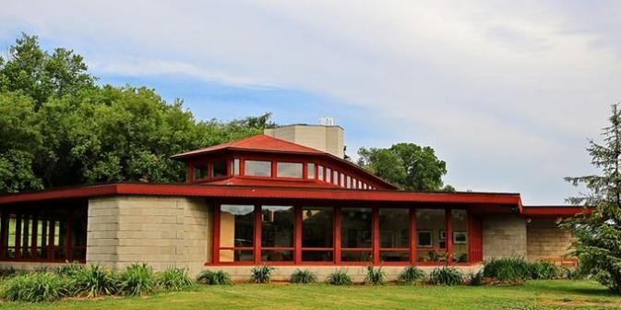

DALC will provide drinks, coffee, tea and snacks. Bring your own lunch!