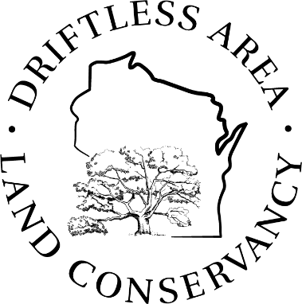**Board Meeting Agenda**

**Noon – 4:00 PM, Wednesday, June 4, 2025**

**Wild Oaks Preserve, 277 Brunson Road, Belleville, WI**

Meeting Goals/Learning Objectives

* Board members have a better understanding of the breadth and complexity of conservation easement stewardship and how much it costs
* Board members have a deeper understanding of DALC’s capacity to both own and manage land AND to hold and steward conservation easements
* The DALC team has a vision and framework for how we decide on land protection strategies (especially owning vs holding an easement)
* The DALC team has identified next steps to further refine our decision making regarding land protection strategies, and to build out our resources to protect land

|  |  |
| --- | --- |
| 11:00 – 11:45 | OPTIONAL – Bring a sack lunch for a picnic at Wild Oaks! |
| 11:45 | Gathering Time |
| Noon | Call to Order, review and accept agenda  Fun Team Building: Since we are meeting in a barn, what is the strangest place you’ve ever had a professional meeting? |
| 12:30 | Presentation: Setting the Stage, Conservation Easements & Stewardship |
| 1:00 | Small groups: WW*dalc*D? Let’s steward some easements! |
| 1:30 | Hike to the council ring (5 minutes)  Discussion: Why protect land, and how?   * Strategies to protect land (DALC uses 6!) * Our portfolio of preserves – for each preserve:   + Why do we own it? Why not a CE?   + Basic stats: how acquired, endowment, land mgt budget |
| 2:15 | Small groups: Own it, Ease it, Leave it! Let’s evaluate some land protection opportunities! (Return to barn) |
| 3:15 | Presentation: What do we need in staff time and resources to protect land in the Driftless? What are other land trusts doing? |
| 3:30 | Discussion: Takeaways and next steps   * Reflections and A-ha moments? * Next Steps? |
| 4:00 | Adjourn   * Optional: tour of the Wild Oaks Stewardship House (20-30 min) |